18.2

> x = c(8.9,36.6,36.8,6.1,6.9,6.9,7.3,8.4,6.5,8.0,4.5,9.9,2.9,2.0)
> y = c(1,2,1,1,1,2,1,1,2,1,1,2,2,1)
> x1 = x[y==1]
> x2 = x[y==2]
> miu1 = mean(x1)
> miu2 = mean(x2)
> t.test(x1,x2)

Welch Two Sample t-test

data: x1 and x2
t = -0.38243, df = 6.6051, p-value = 0.7141
alternative hypothesis: true difference in means is not equal to 0
95 percent confidence interval:
-19.46984 14.10539
sample estimates:
mean of x mean of y
9.877778 12.560000

Looking at the confidence interval, we can’t conclude that miu 1 and miu 2 are different because the interval also cover 0 as well

18.3

> x1 = c(-0.27, -0.14, 1.61, 0.09, 0.00, 2.07, 0.56, -1.67, -0.51, -0.54)
> x2 = c(-0.32, 0.20, 1.93, 0.54, 0.75, 1.77, 0.84, -0.29, -0.33, 0.17)
> different = x1 - x2
> mean(different)
[1] -0.406
> sd(different)
[1] 0.4650496
>plot(x1,x2)

> y1 = c(-0.27, -0.14, 1.61, 0.09, 0.00, 2.07, 0.56, -1.67, -0.51, -0.54)
> y2 = c( 0.20 , 0.54, -0.33, 1.93, -0.32, 1.77, 0.75, 0.17, -0.29, 0.84)
> mean(y1)
[1] 0.12
> mean(y2)
[1] 0.526
> sd(y1)
[1] 1.079496
> sd(y2)
[1] 0.8175193

7.42
> data = c(418,421,421,422,425,427,431,434,437,439,446,447,448,453,454,463,465)
> boxplot(data)
> qqnorm(data)

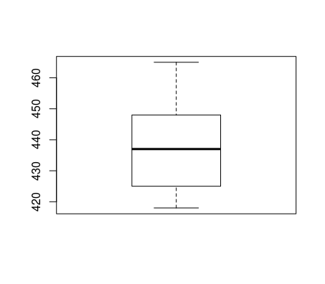Illustration 1: Box Plot

Looking at the box plot, I can see that the mean is around 438. In addition, the min also tend to be around 420 and the max is more than 460, maybe 463. Another interesting thing is that the data tend to focus more toward the left(down) versus the right(up). By looking at the plot, we can see that the plot is more skwewed toward the left

The qq plot seems to come from a normal distribution. But there are still several points that did not follow a straight line. However, those points are minimal so I would say that the data is from a normal distribution
